Power BI Sales Analysis Dashboard – Project Report

Prepared by: Archita Verma

Tools Used: Microsoft Power BI, Power Query, DAX, Microsoft Excel

# 1. Project Overview

This project involved building a comprehensive Sales Analysis Dashboard using a multi-sheet Excel dataset (`sales.xlsx`). The primary goal was to derive key business insights and visualize sales performance, returns, and customer behavior to simulate real-world data analysis scenarios.

# 2. Dataset Description

The Excel workbook contained the following sheets:  
- Orders – Main transactional sales data  
- Rest of the Orders – Additional order entries  
- 2009 Orders – Archived sales records from 2009  
- Returns – Records of returned products with Order IDs  
- Users – User demographic and location details  
  
All tables were integrated and cleaned to form a unified data model using Power BI.

# 3. Objectives

- To create a consolidated view of company-wide sales performance  
- To identify trends in orders, product categories, and regional sales  
- To analyze customer distribution and order behavior  
- To assess the impact of product returns  
- To build an interactive dashboard using filters, slicers, and visuals

# 4. Data Preparation & Modeling

Power Query Editor was used to clean and transform data:  
- Removed duplicates, handled null values  
- Merged order tables for unified analysis  
- Parsed date columns and standardized formats  
  
Relationships were created between fact and dimension tables:  
- Orders ↔ Returns (via Order ID)  
- Orders ↔ Users (via User ID)  
  
DAX Measures were written to calculate:  
- Total Sales  
- Number of Orders  
- Return Rate (%)  
- Average Sales per Customer  
- Category/Sub-Category Performance

# 5. Dashboard Features

The final Power BI dashboard includes the following insights:  
  
🔹 Overall Sales Overview  
- KPIs: Total Sales, Total Orders, Total Returns, Avg. Sales per Customer  
- Year-wise and Month-wise Sales Trends (Line Charts)  
  
🔹 Category & Sub-Category Analysis  
- Category-wise and Sub-category-wise sales performance (Bar Charts)  
- Filters by Region, Year, and Product Category  
  
🔹 Returns Analysis  
- Return Count and Return Rate by Category  
- Visual comparison of Returns vs. Orders (Stacked Column Chart)  
  
🔹 Geographic Distribution  
- Regional Sales by State/Region using Map Visual  
- User Distribution by Region  
  
🔹 Customer Insights  
- Top Customers by Sales Volume  
- Repeat Purchase Behavior Indicators

# 6. Key Learnings

- Gained hands-on experience in data modeling and dashboard creation  
- Strengthened skills in Power Query for data cleaning  
- Practiced DAX to write dynamic measures  
- Improved storytelling using interactive visuals and slicers

# 7. Conclusion

This project helped simulate a real-world data analytics scenario where messy and scattered data is transformed into meaningful insights through visualizations. The dashboard provides a full picture of sales performance and can be used by management to make data-driven decisions.

# 8. Future Enhancements

- Add customer segmentation analysis (e.g., RFM)  
- Integrate product profit margins if available  
- Enable forecasting using time series models

# Dashboard Screenshots

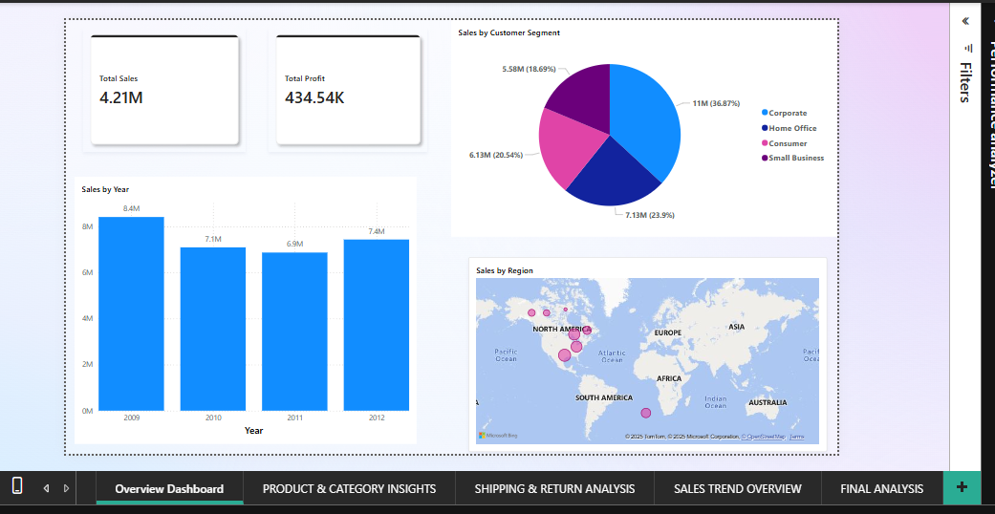

Figure 1: Sales KPIs and Overview

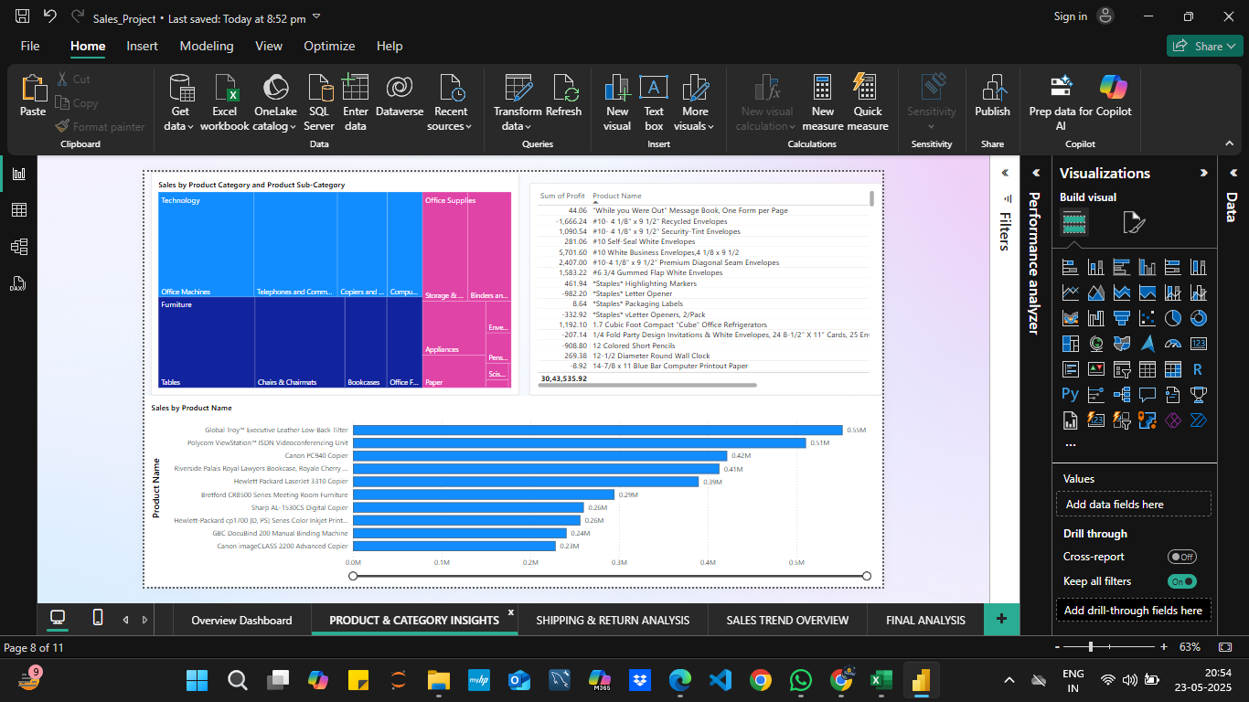

Figure 2: Category and Sub-Category Performance

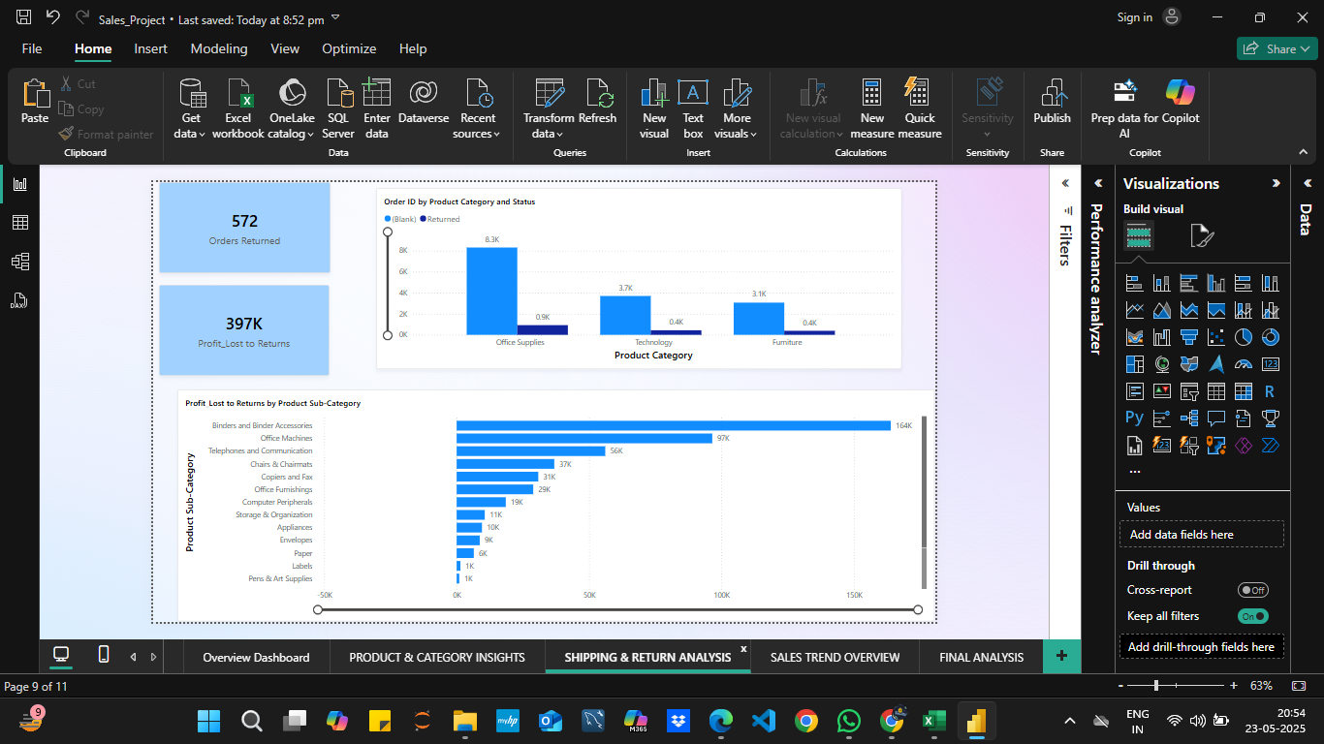

Figure 3: Returns Analysis

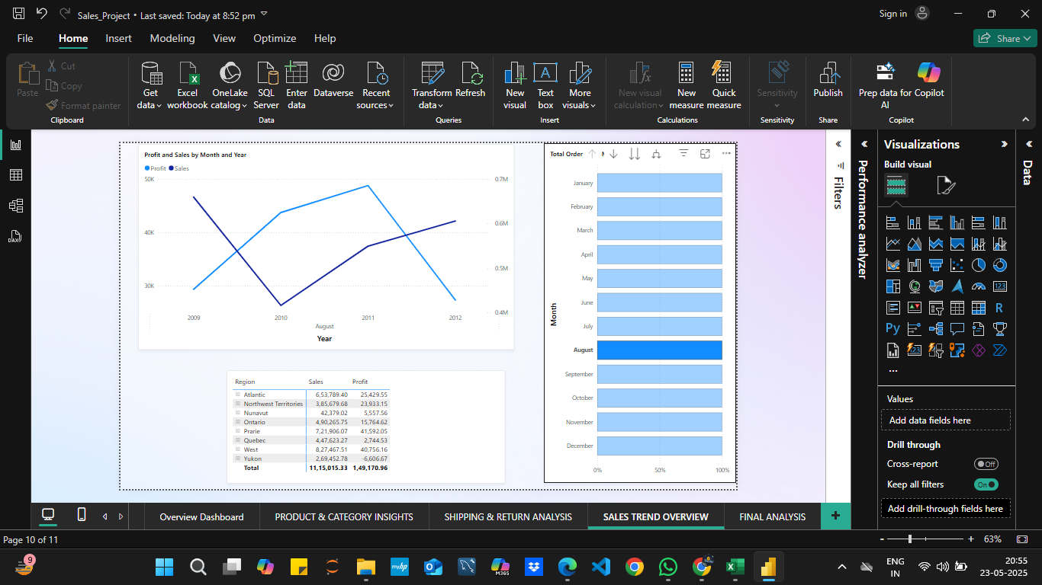

Figure 4: Geographic Sales Distribution

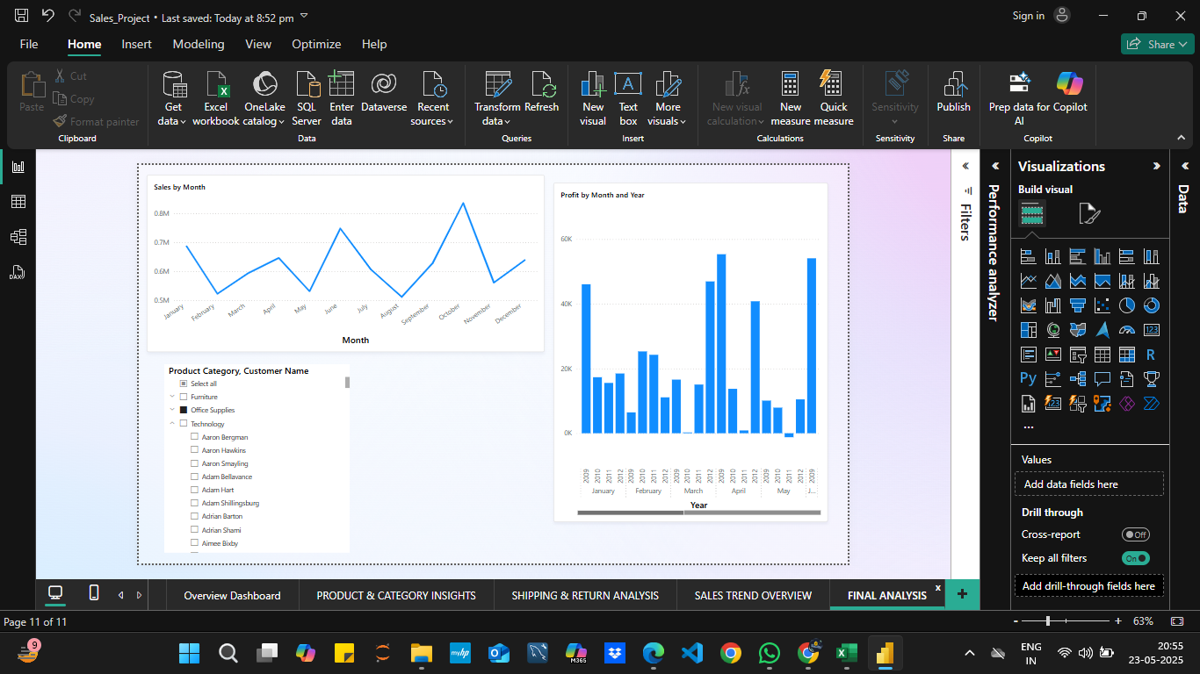

Figure 5: Customer Insights Dashboard